**SHELL SCRIPTING**

1) Given a list of integers and a threshold N, return a tuple of 2 values, first should be the sum of squares of all the even numbers that are less than N. the second should be the count of those even numbers.   
Sample Input: [1, 2, 3, 4, 5, 6], Threshold N= 5   
Expected Output: (20, 2) # Sum of squares: 4+ 16 = 20; Count: 2 (2 and 4) ?

|  |
| --- |
| #!/bin/bash    # Usage: ./even_squares.sh N num1 num2 num3 ...  # Example: ./even_squares.sh 5 1 2 3 4 5 6    if [ "$#" -lt 2 ]; then  echo "Usage: $0 N num1 num2 num3 ..."  exit 1  fi    N=$1  shift # Remove N from arguments  sum=0  count=0    for num in "$@"; do  if [ "$num" -lt "$N" ] && [ $((num % 2)) -eq 0 ]; then  square=$((num * num))  sum=$((sum + square))  count=$((count + 1))  fi  done    echo "($sum, $count)" |

2) List some of the commonly used shell commands?

Ls  
mv  
mkdir  
touch  
cp  
rm  
telnet  
curl

-------------------------------------------------------------------------------------------------------------  
  
3) Write a shell script to list all processes?

ps –ef | awk –F “ “ ‘{print $2}’

-------------------------------------------------------------------------------------------------------------

4) Write a script to print only errors from a remote log?

curl <url-of-the-file> | grep TRACE > trace.logs

-------------------------------------------------------------------------------------------------------------

5) Write a shell script to print numbers divided by 3 & 5 and not 15?

They can also ask   
 Print even numbers ---> divisible by 2   
 Print odd numbers ----> not divisible by 2  
 Print numbers divisible by 3 -->   
 Print prime numbers

Divisible by 3 --> lets say you are given (1to 15 ) ---> in this divisible by 3 are (3, 6, 9, 12, 15) [if condition]  
divisible by 5 ---> |||-ly (5, 10, 15) [if condition]

And not divisible by 15 --> not divisible by 15 [not if condition]  
  
---> you should ask interviewer for how much range you want me to print

Ex; lets assume interviewer said print numbers b/w 1 to 100 (for loop)

#!/bin/bash

for i in {1..100}; do  
if ([ $(expr $i % 3) -eq 0 ] || [ $(expr $i % 5) -eq 0 ]) && [ $(expr $i % 15) -ne 0 ];  
then  
 echo "$i"  
fi  
done”

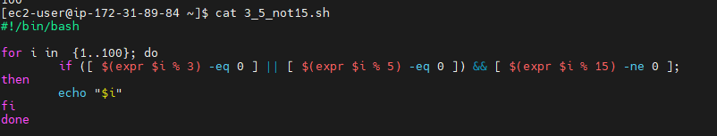

6) Write a shell script to print number of ‘s’ in mississippi ?  
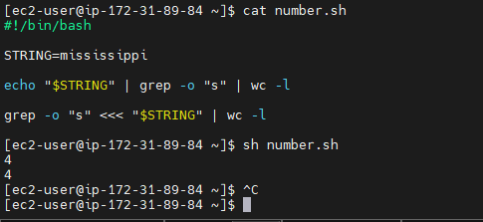c

-------------------------------------------------------------------------------------------------------------  
7) How will you debug the shell script ?

set –x

-------------------------------------------------------------------------------------------------------------

8) what is crontab in linux ? Can you provide an example of usage ?

To run schedules tasks

-------------------------------------------------------------------------------------------------------------

9) How to open a read-only file

vi –r file.txt

-------------------------------------------------------------------------------------------------------------

10) What is the difference between soft and hard link ?

Soft links are like if we create a soft link for a file or directory and delete the org file it will also be delete the soft link,.  
Where as when we create a hard link it wont even if we delte the org file it wont delete the hard link.  
-------------------------------------------------------------------------------------------------------------

11) What is the difference between break and continue statements?  
BREAK – breaking the execution  
CONTINUE – CONTINUING the execution (SKIP) --Skip this and continue next

12) What are some disadvantages of Shell scripting ?

Shell scripting has the following disadvantages:

. Errors are frequent and costly, and a single error can alter the command.

. The execution speed is slow.

Bugs or inadequacies in the language's syntax or implementation.

· Large, complex tasks aren't well suited to it.

Contrary to other scripting languages, etc., it provides a minimal data structure.

Every time a shell command is executed, a new process is launched.

-------------------------------------------------------------------------------------------------------------  
13) What are the different types of loops and when to use ?  
We have --> for loop, while loop, do while loop

-------------------------------------------------------------------------------------------------------------

14) Explain about a network troubleshooting utility?  
Tracerout

-------------------------------------------------------------------------------------------------------------

15) How will you sort list of names in a file

sort

-------------------------------------------------------------------------------------------------------------

16) How will you manage logs of a system that generate huge log files every day?

As a linux admin you manage lot of applications and it omit lot of logs ans if your application is realtime user facing application it will produce 100000 n no of logs and due to this the disk storage will be piled up. to manage it in an efficient way we can use

logrotate (gzip, zip)

17) Write a script to print numbers **divisible by 7 but not by 2**.  
|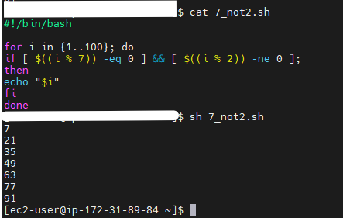

19) List all the files under /etc serach for the files that are modified in last 30 days

find /etc/ -iname "*" -type f -mtime -30

18) Write a script to print **prime numbers** from 1 to 100.  
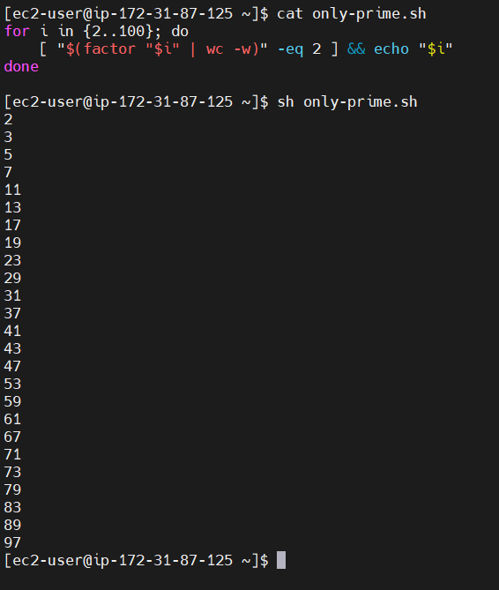

19) Write a shell script to print last 5 modified files in a directory?  
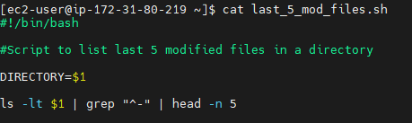

20) **Find Duplicate Files by Name**

### **📝 Problem Statement:**

Write a shell script that:

* Takes a directory path as an argument
* Finds **files with duplicate names** (regardless of their paths)
* Prints the file names and the number of times they appear

### **✅ Example:**

If your directory contains:

/home/user/data/report.txt  
/home/user/logs/report.txt  
/home/user/data/summary.log  
/home/user/archive/summary.log  
/home/user/tmp/test.txt

Your script output should be:

report.txt - 2  
summary.log - 2

ANS:  
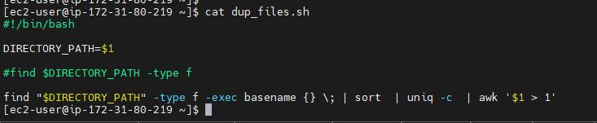  
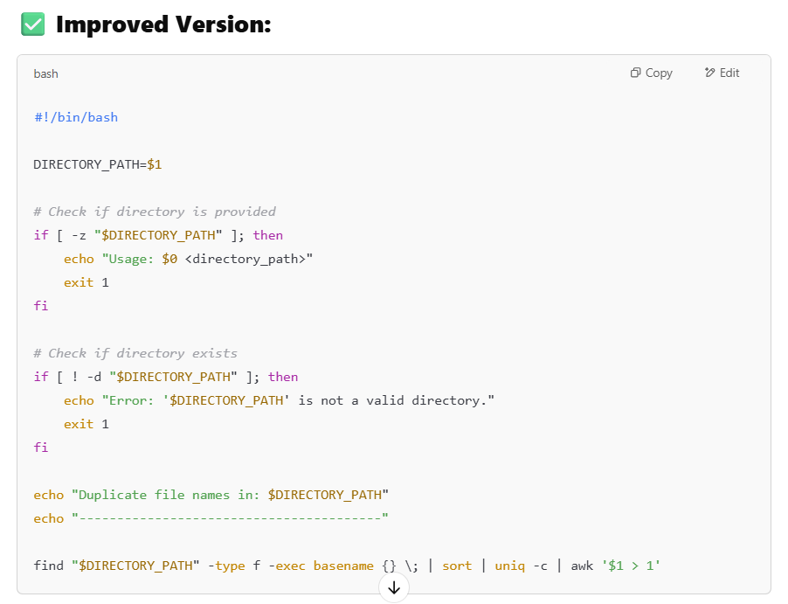  
-----------------------------------------------------------------------------------------------------------------

21) Calculator

|  |
| --- |
| while true  do  echo "1. Add"  echo "2. Subtract"  echo "3. Multiply"  echo "4. Divide"  echo "5. Average"  echo "6. Quit"    read -p "Enter your choice: " choice    case $choice in  1) read -p "Enter Number1: " number1  read -p "Enter Number2: " number2  echo Answer=$(( $number1 + $number2 ));;  2) read -p "Enter Number1: " number1  read -p "Enter Number2: " number2  echo Answer=$(( $number1 - $number2 ));;  3) read -p "Enter Number1: " number1  read -p "Enter Number2: " number2  echo Answer=$(( $number1 * $number2 ));;  4) read -p "Enter Number1: " number1  read -p "Enter Number2: " number2  echo Answer=$(( $number1 / $number2 ));;  5) read -p "Enter Number1: " number1  read -p "Enter Number2: " number2  sum=$((number1 + number2))  echo Answer=$( echo "$sum / 2" | bc -l );;  6) echo "Quiting"  exit;;  esac  done |

CPU  
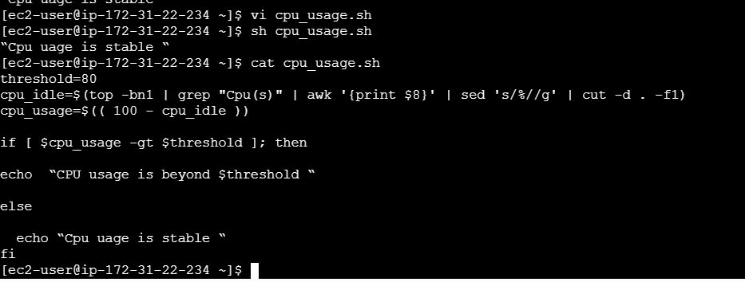

<MEmory>

free -m | grep "Mem" | awk '{print $3/$2 * 100}' | cut -d . -f  
  
  
----------------------------------  
  
Q) Write a shell script to read service name from a file called service.txt and restart the service if it is not running?

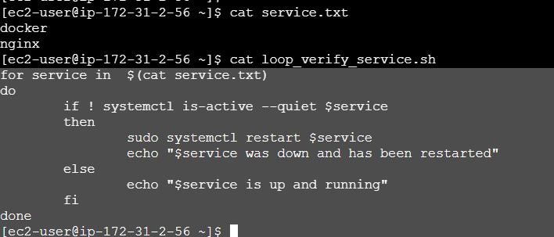

Q) Print numbers from 1 to 10 using a for loop.

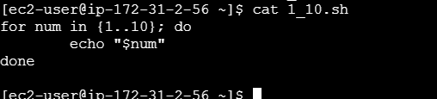

Q) Print even numbers between 1 and 20 using a while loop.

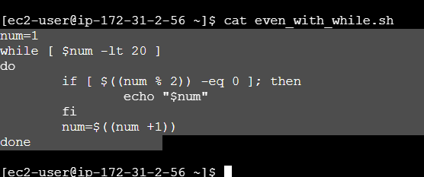

Q) Print the multiplication table of a given number (e.g., 5).

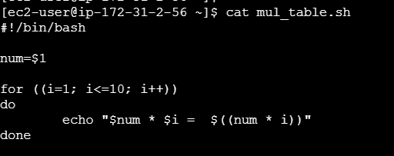

Q) **How to read a file line by line?**

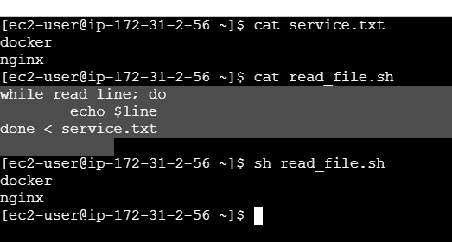

Q) **Write a script to rename all** .txt **files to** .log**.**  
  
  
  
**Q) Find and delete all empty files in a directory.**

find /path/ -type f -empty –delete

Write a script to backup logs and delete the originals after backup.   
Answer:   
#!/bin/   
LOG_DIR="/var/log"   
BACKUP_DIR="/backup"   
mkdir -p $BACKUP_DIR   
tar -czf $BACKUP_DIR/logs_$(date +%F).tar.gz $LOG_DIR/*.log   
rm $LOG_DIR/*.log